

GRIDTALK
Release Notes

Document Revision: 5 | 24 February, 2007
Applicable to: | GridTalk Version 4.0

Table of Contents

Table of Contents 2
Revision History 3
Text Conventions 3
1 Overview 4
1.1 Description 4
1.2 Product Information 4
2 Pre-requisites 4
2.1 Upgrade requirements 4
2.2 System Requirements 4
3 Installation Instructions 5
3.1 Full Installation 5
3.2 Upgrade Installation 5
3.3 Patch Installation 5
4 Change Notes 5
4.1 V4.0.0 – (Build 4.0.0) – 16/03/2006 5
4.1.1 Component Upgrades 5
4.1.2 Changes to Existing Functionalities 6
4.1.3 Enhancements 7
4.2 V4.0.1 – (Build 4.0.1) – 09/05/2006 10
4.2.1 Component Upgrades 10
4.2.2 Changes to Existing Functionalities 10
4.2.3 Enhancements 14
4.3 V4.02 – (Build 4.0.2) – 24/02/2007 17
4.3.1 Component Upgrades 17
4.3.2 Changes to Existing Functionalities 18
4.3.3 Enhancements 23
5 Known Issues 29
5.1 Functional Issues 29
5.1.1 Operational Issues 29
5.1.2 Communication Issues 29
5.1.3 Document Issues 29
5.2 Non-Functional Issues 29
6 Release Packs 29
6.1 Installation Packs 29
6.1.1 Build 4.0.0 29
6.1.2 Build 4.0.1 30
6.1.3 Build 4.0.2 31
6.2 Upgrade Packs 32
6.2.1 Build 2.4.8 – 4.0.1 32
6.3 Patches 33
6.3.1 Build 4.0.0 – 4.01 33

Revision History

Revision | Date | Name | Comments
1 | 15 March, 2006 | Neo Sok Lay | Initial creation – build 4.0.0
2 | 09 May, 2006 | Neo Sok Lay | Addition for build 4.0.1
3 | 29 May, 2006 | Neo Sok Lay | Addition for 4.0.1 release package on SunOS
4 | 15 August, 2006 | Neo Sok Lay | Addition for upgrade pack for build 2.4.8 – 4.0.1
5 | 24 February, 2007 | Neo Sok Lay | Addition for build 4.0.2

Text Conventions

In this document the following text conventions are used:

- Text that is bold and italicized represents registered and trademarked product names or standards code names. For example: Internet Explorer, GridTalk, Microsoft Windows, RosettaNet.
- Text that is in bold represents application elements that cause the screen or database to change. This includes the names of tabs, buttons, and hyperlinks functions. For example, Administration (tab), Browse (button), Refresh (hyperlink function).
- Text that is in Title Case, upper and lower-case letters, represents screen fields.
- Text that is italicized represents specific field values.
- Text that is blue and underlined represents a script name or program provided with the release, or a defect number such as GNDB00012233.

- Text that is red and in bold represents important information that need to be taken note of.

- Text that is blue and in bold represents information that are worth taking note of.

Overview

Description
This release is a major revision of the 2.4 series to improve performance and stability of the GridTalk application, especially in XML processing and database access.

This release is built on top of V2.4.8 and all existing GridTalk installations of V2.4 or earlier need to upgrade to V2.4.8 before proceeding to upgrade to this release.

Product Information
Application Server | JBoss 4.0.2
Database Engine | MySQL 5.0.15 (Windows), 5.0.18 (Linux), 5.0.21 (SunOS)
Java Run-time Engine (JRE) | 1.5.0_05 (Windows), 1.5.0_06 (SunOS-amd64), 1.5.0_08 (Linux), 1.5.0_10 (SunOS-sparcv9)
RosettaNet Compliance | RNIF 1.1 and RNIF 2.0
Supported API Standards | XSLT 1.0
Supported API Standards | XPath 1.0
Supported API Standards | XML Schema
Supported API Standards | SOAP 1.2
Convertor API | GN-CONVERTOR 1.1.2
Convertor API | JExcelApi 2.5.7
Convertor API | POI 2.5.1-final-20040804
XML API | GN-XML 1.1.1
XML API | DOM4J 1.6.1
XML API | JDOM 1.0
XML API | MSV 20030225
XML API | ISO Relax 20041111
XML API | Saxon 6.5.5
XML API | Xerces2-Java 2.7.1
XML API | Jaxen 1.1b7

Pre-requisites

Upgrade requirements
This upgrade release notes assume GridTalk has been upgraded to V2.4.8 release.

System Requirements
Hardware | Minimum | Recommended
CPU type | Intel Pentium 3 | Intel Pentium 4 or Equivalent
CPU speed | 1.7 GHz | 2.4 GHz or higher
RAM | 512 MB | 1 GB or higher
Hard disk free space | 1 GB | 5 GB or higher
Internet Connection Speed | 512 Kbps | 10 Mbps or higher

Supported OS | Windows 2000 (SP4), Windows XP (SP2), SunOS (AMD 64-bit, Sparcv9), Linux
Supported Internet Browsers | Internet Explorer 6.0 or later, Mozilla/Firefox 1.5 or later

Installation Instructions

Full Installation
- Follow the instructions in section 6.1 for the relevant build to carry out a new installation of the release.

Upgrade Installation
- For those existing installation of GridTalk as Windows Service, stop the “jBoss” and “mySQL” Windows Services before proceeding with the upgrade; otherwise, stop the GridTalk application (if running) using the shutdown.bat script in GRIDTALK_HOME/bin directory.

- It is recommended to backup your current working copy of GridTalk to some backup file system prior to performing the upgrade.

- Follow the instructions in section 6.2 to carry out a version upgrade from the relevant version.

Patch Installation
- For those existing installation of GridTalk as Windows Service, stop the “GridTalk_AS”, “GridTalk_DB” and “GridTalk_Logger” Windows Services before proceeding with the patch; otherwise, stop the GridTalk application (if running) using the shutdown.bat script in GRIDTALK_HOME/bin directory.

- It is recommended to backup your current working copy of GridTalk to some backup file system, prior to performing the patch.

- Follow the instructions in section 6.3 for the respective build to carry out a patch to that release.

Change Notes

V4.0.0 – (Build 4.0.0) – 16/03/2006

Component Upgrades

JBoss Application Server
The JBoss Application Server has been upgraded from v3.2.2 to v4.0.2. This upgrade improves the stability and performance of the application server.

MySQL Database Engine
The MySQL database engine has been upgraded from v4.0.0alpha to v5.0.15. This upgrade improves the stability and performance of the database engine.

Java Run-time Engine (JRE)
The JRE version has been upgraded from v1.4.2_05 to v1.5.0_05. This upgrade improves the performance of the core executing engine of the software.

XML APIs
The following XML APIs are upgraded to improve performance during XML processing:

API | Previous Version | Upgraded Version
GN-XML | 1.0.16 | 1.1.0
DOM4J | 1.4 | 1.6.1
JDOM | b9 | 1.0
ISO Relax | 20030108 | 20041111
Saxon | 6.5.3 | 6.5.5
Xerces2-Java | 2.4.0 | 2.7.1
Jaxen | 1.0 | 1.1b7

Convertor APIs
The following Convertor APIs are upgraded to improve performance and resolve potential convertor issues that user may encounter in earlier versions:

API | Previous Version | Upgraded Version
GN-CONVERTOR | 1.0.7 | 1.1.0
JExcelApi | 2.3.7 | 2.5.7
POI | 2.0 | 2.5.1-final-20040804

Changes to Existing Functionalities

Bug Fixes

GNDB00026658
Auto-grouping of exported files under a directory named after the exported user document under the Host Directory breaks existing customer implementations (V2.4.8).

The Port configuration now contains an additional File Grouping option that allows the export files to be organized in three ways:
- Group All Files – All exported files (user doc, grid doc and attachment files) will be grouped under a directory named after the exported user doc file under the Host Directory.
- Group Attachments Only – The user doc will be exported under the Host Directory; the grid doc and attachment files will be grouped under a directory named after the exported user doc file under the Host Directory.
- No Grouping – All files will be exported directly under the Host Directory.

Sample Snapshots:
Port
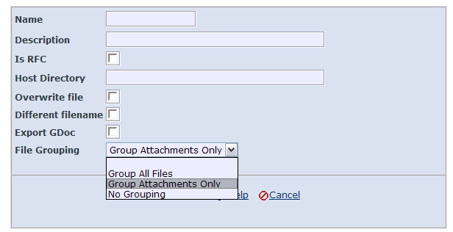

GNDB00026534
Audit filename is not missing for incoming documents when both the initiator and responder are of GridTalk V2.3.4 and above.

The problem is fixed. As long as one of the transacting parties is of the fixed version, the audit filename will be populated correctly. The existing documents (transacted prior to fix) in Inbound folder, however, will still be missing the audit filename after upgrading to the fixed version.

GNDB00026214
RosettaNet attachments extracted out from incoming RosettaNet business message are corrupted.

The problem is fixed. The extracted attachments of prior transactions, however, will still be corrupted.

GNDB00026188
Validation failed for RosettaNet Service Content if the content contains special encoded character.

The problem is fixed.

Others

StartUp and Shutdown Changes
- On some occasions, the time to start up MySQL database engine may take a longer time than usual, which may cause application deployment to fail if the database has not been started during deployment.

To overcome this, a script is run repeatedly to ping for ready for connections status of the database engine before starting the JBoss Application Server. This script may give a beeping sound when the database has not been fully started yet.

- During startup, an external logging server will also be started to listen for logging events from the GridTalk application on port 12345 by default.

This logging server is hidden usually and will be stopped automatically during shutdown. On occasions whereby the application is not shutdown using the shutdown.bat, the logging server could be stopped manually using the stopLogServer.bat script.

For installation as Windows Services, the service.bat will install the external logging server as Windows Service as well.

Enhancements

Backend Program Changes

Backend Senderlite supports Process Instance ID
The Backend Senderlite program now supports additional parameter: -PS “process_instance_id”.

This enhancement may serve two purposes:
- The specified process_instance_id enables a RosettaNet response message (imported file) to be linked back to the Process Instance of the requesting message.
- The specified process_instance_id can be used as the Process Instance ID of the new Process Instance to be initiated based on the RosettaNet requesting message (imported file).

This parameter takes precedence of –R “rn_profile_uid”.

Process Changes

Handling of 0A1 Failure Notification
There are various changes towards the handling of 0A1 PIP.
- All 0A1 PIP now contains a tracking identifier that indicates the PIP that is failing.
- All incoming 0A1 PIP will now automatically fail the Process Instance that is indicated as failing, even if the Process Instance status is already completed successfully.
- Cancelling of a Process Instance (except 0A1 process instance) will now automatically initiate a 0A1 PIP to be sent out to the partner end.
- Cancelling is also enabled for Process Instances that have already completed successfully (except 0A1 process instance).

Alert Changes

Alert Notification via JMS
Alerts can now be notified via JMS messaging.

The flexibility of the Message Template allows any kind of textual content to be transmitted to the receiving end. Message properties are also supported to enable message filtering at the receiving end, if necessary.

Each JMS type Message Template is linked to a JMS Destination which can be fully configured using the user interface.

Retry of alert notification is supported on occasions of failure to send to the specified JMS Destination.

Sample Snapshots:
Message Template – JMS Type
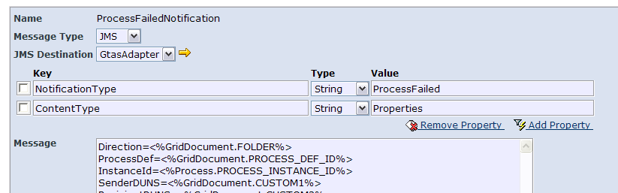
On selection of JMS Message Type, the user would choose the JMS Destination (or create using the diversion link ) and configure the Message Properties, if any.

JMS Destination
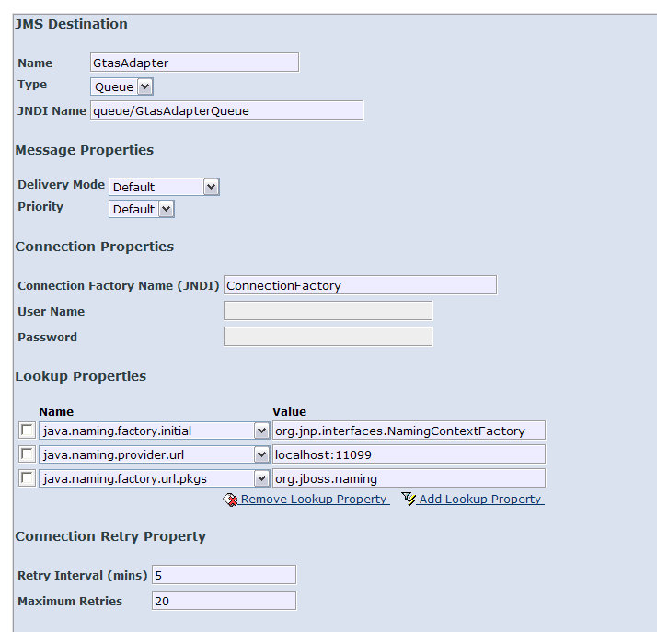
- Name – the name of the JMS Destination, must be unique
- Type – Queue or Topic
- JNDI Name – the JNDI lookup name of the target destination
- Delivery Mode – Persistent, Non-Persistent, or Default (the default set in the target JMS provider)
- Priority – 0-9, or Default (the default set in the target JMS provider)
- Connection Factory Name (JNDI) – JNDI lookup name for the JMS Connection Factory
- User Name – Authentication user for the JMS Connection, if any
- Password – Authentication password for the JMS Connection, if any
- Lookup Properties – JNDI lookup properties for the JMS Connection Factory and Destination
- Retry Interval (mins) – Number of minutes between attempts to send out alerts via this JMS Destination. Minimum is 1 minute. That means alerts will be sent out in batches to minimize the number of JMS connections to the target destination.
- Maximum Retries – Maximum number of retries for each alert that failed to send out via this JMS Destination on first attempt. 0 means no retry; -1 means infinite retries; positive integer means the number of retries. For example, if the target destination is not valid, and the Maximum Retries is 3, then a total of 4 attempts will be performed to send the alert via the JMS Destination.

JMS Destination Listing
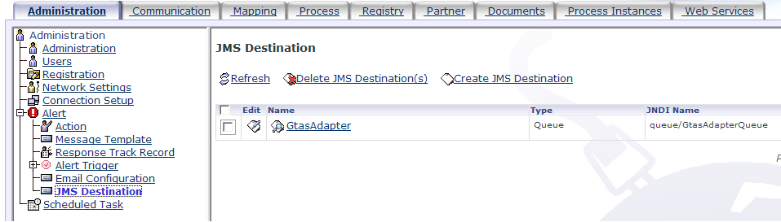
- The user may create, update and delete JMS Destinations(s) from the Administration tab, under the Alert navigation tree.
- A JMS Destination can only be deleted from the database if it is not associated from any Message Template.

V4.0.1 – (Build 4.0.1) – 09/05/2006

Component Upgrades

Convertor APIs
The GN-CONVERTOR is upgraded to version 1.1.1. This new version includes conversion support for EDI-X12 format.

Changes to Existing Functionalities

Bug Fixes

GNDB00027090
The current certificate replacement feature is unknowingly replacing the expired certificate database record with the new certificate and removing the new certificate database record from the database. This behavior results in stale referencing in the existing business certificate mappings or security profiles that are already configured with the new certificate. Hence cause failures in retrieval of those business certificate mappings and security profiles. In addition, the record of the expired certificate is also lost and may hinder future audit tracking.

This problem is fixed to retain the expired certificate record but revoking it, and update the relevant existing references to the revoked certificate to the new certificate that is configured to be the pending certificate for the expired certificate.

Please note that the certificate replacement feature works on the assumption that there is only one pending certificate configured each time for an expired certificate. If more than one pending certificate is defined, one of those pending certificates will be randomly picked to replace the expired certificate.

GNDB00027030
The Alert Trigger configuration for the Role recipient type allows selection of the role “User Administrator” and creation of new roles. This is confusing to the users as there is no “User Administrator” role, and creation of new roles is also redundant as there is no management of roles and access rights.

This problem is fixed to remove the unnecessary links and records.

GNDB00026989
During the packaging of RosettaNet business messages, cononicalization of the document is necessary. During the canonicalization step, if the XML document header line (ie. <?xml version="1.0" encoding="..."?> is more than 40 bytes, a StringIndexOutOfBounds exception will be thrown.

For most common XML header line, i.e. <?xml version=”1.0” encoding=”UTF-8”?>, it is 40 bytes. For other types of encoding, the header line may be longer than 40 bytes.

This problem is fixed to allow XML header line longer than 40 bytes, up to a maximum of 100 bytes.

GNDB00026982
After import of a JMS Destination configuration, alert notifications that are supposed to be sent to the target destination are not sent.

The reason is that the timer record for the JMS Destination is not created or updated during import configuration. A workaround is to Edit and Save the JMS Destination after it is imported.

This problem is fixed.

GNDB00026947
After a Channel is configured, any change to its related profiles (Communication, Packaging or Security) through their respective listing Edit functions, will not immediately take effect when the document is sent via the affected channel. The changes take effect only after restarting the application.

This problem is fixed.

GNDB00026940
For RNIF 1.1 implementation, when receiving RosettaNet Acknowledgement (RN_ACK) with non-repudiation, schema validation failed due to incomplete OriginalMessageDigest.

In versions prior to v4.0.0, the RN_ACK does not contain (no value) the OriginalMessageDigest and DigestAlgoritm, even if Non-repudiation is required. However, in v4.0.0, the DigestAlgorithm contains some value, which requires the OriginalMessageDigest to be present as well, but it is not. Thus schema validation fails.

This problem is fixed. The RN_ACK generated at the sender application will now contain both DigestAlgorithm and OriginalMessageDigest if Non-repudiation is required.

GNDB00026789
Due to change to Port in v2.4.8 (related to GNDB00026658), files exported with filename extension value specified with contain an extra underscore (_) between the filename prefix and filename extension value. This causes inflexibility for those (especially existing customers) who do not want underscore or rather want other kind of separator between the filename prefix and filename extension value.

This problem is fixed by removing the auto-insertion of underscore. Customers that want the underscore or any separator between the filename prefix and filename extension value will need to specify it as part of the Filename field.

GNDB00026787
Control of transactions with partners based on registered number of business connections was not put in place. This implies that the GridTalk customer is allowed to have unlimited number of business connections. This control is critically important as the customer should only be allowed to trade with the number of partners that they pay money for.

The control is put in place as follows:
- Document send and receive functions are only enabled for ‘Enabled’ Partners and when the GridTalk is registered with a valid license. When functions are disabled, sending of document will fail and received document will be rejected for processing.
- The GridTalk Administrator is only allowed to create the number of ‘Enabled’ Partners as there is the number of business connections in the current registered valid GridTalk license.
- The GridTalk Administrator is not allowed to create any ‘Enabled’ Partner prior to registration, or when the registered GridTalk License has expired or has not reached the validity start date.
- When the GridTalk License is renewed, if the business connections entitled in the newer license exceeds the existing number of ‘Enabled’ Partners, one of the ‘Enabled’ Partners will be randomly picked and changed to ‘Disabled’ state.
- When the GridTalk License becomes expired, all the existing ‘Enabled’ Partners will have their state changed to ‘Disabled’.
- Imported ‘Enabled’ Partners (via Import Configuration records function) will have their initial state as ‘Disabled’ after imported into the database. For conflicting partners, this only applies if overwrite option is on.

GNDB00026766
During configuration of Communication Profile for HTTP or Soap-HTTP, although the URL format tip stated that the Port number is optional, the system mandates the input for port number by complaining if port number is not specified. In reality, HTTP URLs may not include port number if the default port is used.

The problem was reported earlier as GNDB00025310 and claimed to be fixed in V2.4.4 (see related release notes for that build). However, this was verified to be falsely claimed. This is now fixed to allow port number to be optional, as stated.

GNDB00026261
GridTalk cannot send via AS2 channel anymore due to some transport headers mismatch. This problem happens since v2.3.4.

The problem is fixed.

GNDB00026249
GridTalk cannot receive message from Backend gt-ibtransporter anymore due to some transport headers mismatch. This problem happens since V2.3.4.

The problem is fixed. The readme.doc for the gt-ibtransporter is also updated to remove redundant transport headers information that could cause confusion.

GNDB00017182
During User Procedure execution, if the procedure type is Shell or Java with native execution, the return value evaluation, if specified, results in a NullPointerException. This causes the user procedure to fail.

Another problem is setting the return value into GridDocument custom field. During configuration, if this setting is done through Edit User Procedure, the setting is not saved. This result in return value not set into the GridDocument during execution.

Both problems are fixed.

GNDB00016355
When a new process definition is being configured with the Import Configuration feature, the RosettaNet service header schema is not automatically updated to include the values from this new process definition. As a result, schema validation will fail when such is process is transacted. Currently a workaround exists, which is to edit and save the process definition configuration again after it is imported.

This problem is fixed to automatically update the service header schema even when the process definition is imported.

Others

Deadlock issue (GNDB00027041)
The current workflow processing during receive of RosettaNet documents is prone to database access deadlock problems. This is caused by the different order of access (retrieval or update) of the same database records by two or more concurrently executing workflows activities, which attempt to acquire transaction locks on the database records in different order.

So far the deadlock situations happen for retrieval of records that are not modification, that is, just for information retrieval only. Thus, to minimize the likelihood of encountering deadlocks, the software is modified to doing away with transaction locks during retrieval of records.

Removed UDDI-related and GridTalk proprietary P2P functionalities (GNDB00026998)
The GridTalk proprietary P2P protocol technology and the UDDI technology are de-commissioned. As such, the following functionalities are removed from the application:
- Partner Watch List
- GridMaster Connectivity
- GridTalk Partner Search and Activations
- Business entity synchronization with GridTalk partners
- Search and configure business entities from UDDI

Revision to Export function (GNDB00026937)
There is some revision to the Export document file overwriting policy. In prior releases, if the Port configuration specifies to Overwrite if exist, all existing files in the target Host Dir will be purged during the export. This is a dangerous thing to do as the Host Dir may contain other files exported earlier and have not been further processed by the backend system.

The function is now modified to follow this policy:
- For Overwrite option, if the directory to export the files to already exists, all the existing files in the directory will stay; if the directory contains existing files with names the same as the files to export, those existing files will be overwritten with the files to export.
- For No Overwrite option, if the directory to export the files to already exists, the existing files in the directory will stay; if the directory contains existing file with name the same as the User Document to be exported, the existing file content will be appended with the User Document file content; if the directory contains existing files with names the same as the GridDocument or user Attachment files, the files will be exported with filenames appended with the current timestamp of export.

Enhancements

Batch Import of Hierarchical Schema Set
In prior versions of GridTalk, if the XML schema files configured contain multiple schemas (i.e. import other schema files), these nested schema files need to be manually copied to the GridTalk schema directory (<GRIDTALK_HOME>/…/data/sys/validation/schema/…). This is very inconvenient for the users and error-prone, since the nested schemas files need to be placed in the correct path location as relatively referred to by the configured XML Schema file.

The application is now enhanced to provide a user interface to allow the users to import the entire set of related schema files at one go, and at the same time make the Schema Mapping File configuration for the necessary root XML Schemas.

Sample Snapshots:
Schema Mapping Files Listing
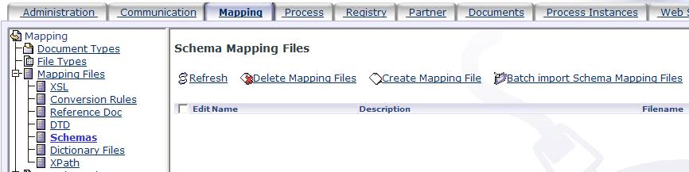
The Import function “Batch import Schema Mapping Files” is accessible from the Schema Mapping Files Listing.

Batch Import Schema Mapping Files – Select Zip File
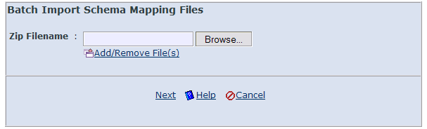
The Import function works on a ZIP file which contains the XML Schema files to be imported into the application. The following figure shows a sample ZIP file that contains the set of XML schemas for PIP 4E1 Notify of Sales Report.

Sample Zip File
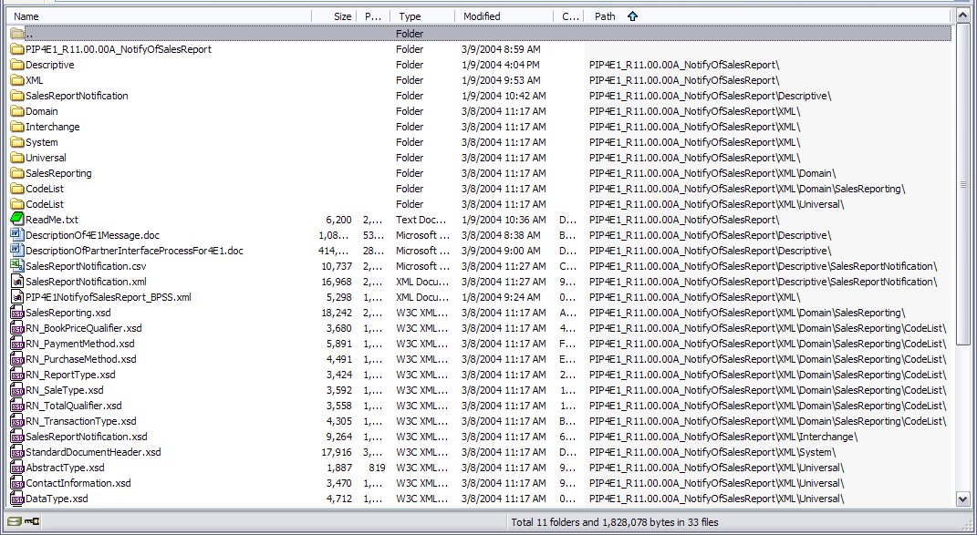

After selection of the ZIP file to import, click on “Next” will bring to the next screen:

Batch Import Schema Mapping Files – Create Schema Mapping
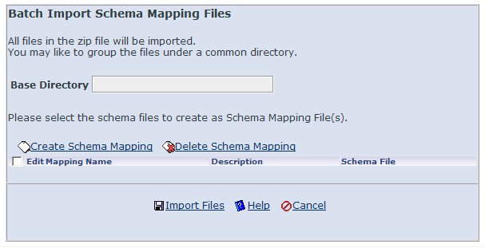
This screen is for:
- Setting a base directory to group the XML Schema files. This is to provide an option to group the imported files in case that they are not based under a common folder in the ZIP file. The Base Directory field serves this purpose and may be left blank.
- Creating Schema Mapping entries from the imported files. This is to allow the user to specify which of the XML Schema files in the ZIP file are to be created as Schema Mapping Files. The “Create Schema Mapping” hyperlink services this purpose. It is not mandatory to specify any Schema Mapping entry.
- Proceed to importing the XML Schema files. The “Import Files” hyperlink serves this purpose.

Schema Mapping
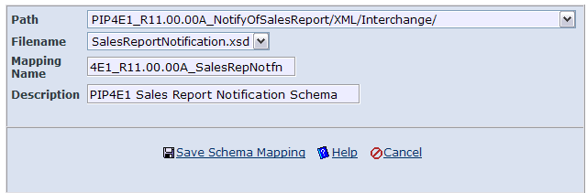
To create a Schema Mapping entry, the following fields need to be entered:
- Path – This presents a list of the folder paths found in the selected ZIP file. Select the path that the XML Schema to be created as Schema Mapping File record is located.
- Filename – On selection of Path, this presents a list of the files found under the Path in the selected ZIP file. Select the filename of the XML Schema to be created as Schema Mapping File record.
- Mapping Name – Enter the name of the Schema Mapping File to be created. This must not be the same as any existing Schema Mapping File record.
- Description – Enter a description for the Schema Mapping File to be created.
Click “Save Schema Mapping” to complete the creation and return to the Batch Import Schema Mapping Files screen.

Batch Import Schema Mapping Files – Import Files
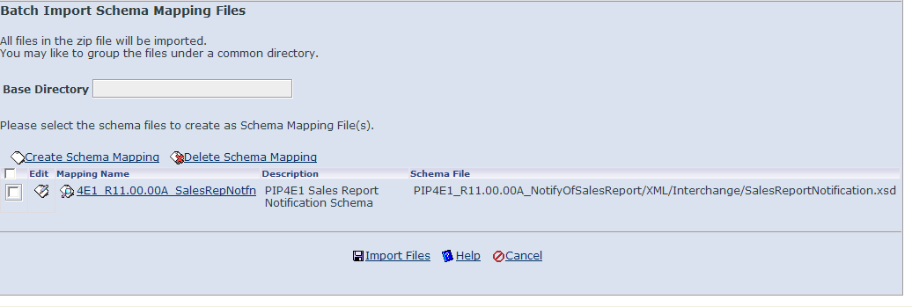
More Schema Mappings may be created using the “Create Schema Mapping” hyperlink. To modify any of the created Schema Mapping entries, click against the corresponding entry. To remove any of the created Schema Mapping entries, tick the check box against the corresponding entry to remove, and click “Delete Schema Mapping” hyperlink.

To confirm the entries and import the XML Schema files, click “Import Files” hyperlink. Otherwise, click “Cancel” to abort the import.

Import Successful
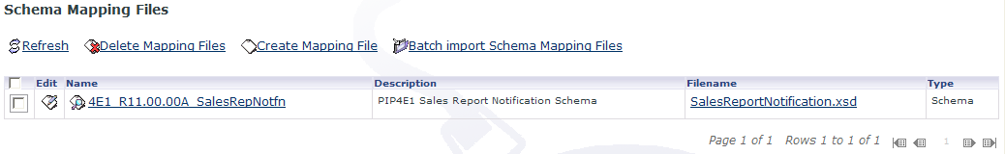
On import successful, the Schema Mapping entry specified will be created as Schema Mapping File record and listed in the Schema Mapping Files Listing.

Other files contained in the ZIP file will also be imported into the GridTalk schema directory, for example, as follows:
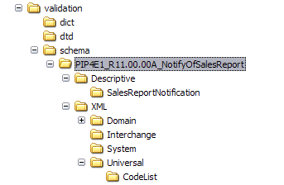

IMPORTANT NOTE:
The imported files that are not created as Schema Mapping File record will not be included during Export Configuration. Thus, for a typical Export/Import Configuration from one system to another, it is recommended to adopt the following approach:
  - Export the configurations from one GridTalk system
  - Get hold of the ZIP file containing all the XML Schemas
  - Import the configurations into the other GridTalk system
  - Import the XML Schemas using the “Batch Import Schema Mapping Files” function. There is no need to create Schema Mapping if the necessary Schema Mapping Files are imported as configurations.

V4.02 – (Build 4.0.2) – 24/02/2007

Component Upgrades

JMS Message Persistence
The JMS message persistence is switched from Hypersonic database to the much more stable MySQL database. The Hypersonic database is proved to be not suitable for transactions with large messages and its behavior is unpredicted when handling large messages.
See Section 4.3.2.1.3.1 GNDB00028057.

XML APIs
The GN-XML is upgraded to version 1.1.1. This version fixes the problem of XML splitting:
- GNDB00027616 – Splitting based on element level more than 2 levels deep fail for multiple occurrences.
See Section 4.3.2.1.3.5 GNDB00027615.

Convertor APIs
The GN-CONVERTOR is upgraded to version 1.1.2. This new version makes various enhancements to EDI-X12 support:
- GNDB00027609 – To make Trailer tag optional in the X12 rule file.
- GNDB00027780 – X12Reader to support multiple separators and line terminators.
- GNDB00027903 – Unable to support X12 documents without physical line breaks.

Changes to Existing Functionalities

Bug Fixes

RNIF Issues

GNDB00027376
The initiator of a RNIF 1.1 double-action process is unable to receive the confirmation from the responder, instead the process failed upon receive of confirmation.

This problem is fixed.

GNDB00027334
The XML Schema for Exception Signal (Exception_MS_V02_00.xsd) wrongly defines two of the error codes:
- PRF_ACTN_GENERR is wrongly defined as PKG_ACTN_GENERR
- PRF_DICT_VALERR is wrongly defined as PKG_DICT_GENERR
This could result in validation of the Exception Signal, on receive or send, to fail if schema validation is enabled.

This problem is fixed.

GNDB00027212
The Initiator of a RNIF process does not abort the process when a Notify of Failure is received from the responder for that process.

This problem is fixed.

GNDB00026715
When Action Timeout is detected (i.e. Time to perform has exceeded) at the initiator end (which is a GridTalk), the process is updated to failed, but no 0A1 PIP is initiated -- this does not follow the RNIF specification. A 0A1 PIP must be initiated when Time to perform has exceeded.

This problem is fixed.

GNDB00026583
For failed process instances, the Detail Reason shows the actual reason or additional information for failure. For newly failed processes, the Detail Reason is being shown in the Process Instance detail page. However, when GridTalk is restarted, the Detail Reason disappeared from the Process Instance detail page of the same failed process. The database, however, still contains the Detail Reason.

This problem is fixed.

GNDB00016210
After the Receipt of Acknowledgement for a received RNIF document is returned and before the document undergoes the private process (i.e. Partner function), if any unexpected error occurs, there is no notification of whatsoever (e.g. NoF or Exception signal) back to sender of document, and the RNIF process is not failed. This could result in discrepancy in the business transactions between the two parties, since the document at one end is not actually processed while the other end may have completed their processing. There may also be orphan process instances with no related documents.

This problem is resolved by returning a Notify of Failure or Exception Signal, depending on whether the Receipt of Acknowledgement has been returned and whether the process is single or double-action, back to the sender on such occasion. There will also not have orphan process instances.

AS2 Issues

GNDB00028098
MDN content generated for AS2 transactions is missing space after the colon between the fields and values.

This problem is fixed.

GNDB00027800
For files transferred using AS2 channel, if the file types are not those expected predefined file types, currently it is treated as "text/plain". This may cause encoding issues wrong interpretation of the content at the receiver side.

This problem is fixed by specifying the more generic “application/octet-stream” content type for unknown file types.

GNDB00027784
Document resend feature is not working for AS2 documents if document failed to send on first attempt, due to an unexpected “NumberFormatException:null” error (which is not handled) during resend.

This problem is fixed.

GNDB00027259
On receive of an AS2 document, although the transaction may complete successfully, the user document in the document Inbound folder is found to be 0 bytes, for any size transferred.

This problem is fixed.

General Operational Issues

GNDB00028057
The Hypersonic database fails to save a large JMS message due to unable to close its cached data file. This causes the document not being able to get processed by the workflow engine.

This problem is resolved by switching the persistence engine to using MySQL (more stable) instead.

GNDB00027928
There has been performance issue when creating records in the database as the database grows. Due to inefficient algorithm for creating new unique key, the amount of existing records in the table affects the time taken to create the new key. In some cases, there may be database connection lost due to timeout.

This problem is fixed by improving the algorithm such that it is no longer affected by the number of existing records in the table, thus improving the performance for creating records and doing away with the database connection lost problem.

GNDB00027902
When doing manual export on an Inbound document, the partner function can only be triggered based on level 1 or 0, it cannot be triggered based on the sender partner.

This problem is fixed.

GNDB00027716
Simultaneous execution of sub-flows in Partner Function may cause “Concurrent Entity Modification” exception.

This problem is fixed.

GNDB00027615
XML splitting does not work for XPath concerning multiple occurrences of elements at the parent levels. For example, /Root/Parent/Leave would only return the values of node Leave under the first occurrence of node Parent. It should return all values of node Leave under all occurrences of node Parent.

This problem is fixed.

GNDB00026716
When export via RFC with command file calling, the command file is restricted to using absolute paths. Any use of relative paths become relative to the working directory of the GridTalk application. This should not be the case as the command file invocation should use the Command File Dir field as the working directory of the command file.

This problem is fixed.

GNDB00026713
No clean-up of abnormally completed partner function runtime workflow records. This could result in performance problem in the future as more of these records get added to the application database.

This problem is resolved by providing an additional option in Housekeeping Settings to clean-up such kind of records.

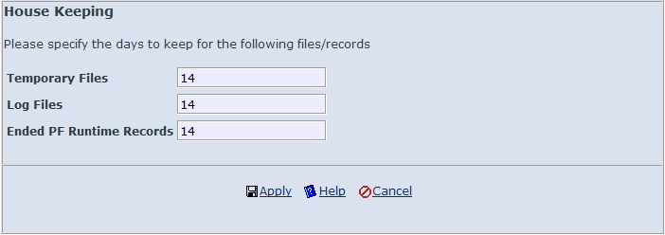
The option Ended PF Runtime Records indicates the maximum age (in days) of the completed partner function runtime workflow records to keep in the application database, any records older than that will be purged during the scheduled housekeeping task.

GNDB00026581
A Record List Retrieval Error is encountered when executing a document Search Query built with an IN operator condition but only specified with a single value in the Value(s) field.

This problem is fixed.

GNDB00026569
Concurrent processing of document encrypting/decrypting/signing/verifying may result in security exception complaining “SPT_DATABASE service named Temp Memory DB is already registered.”

This problem is fixed.

Configuration Issues

GNDB00028076
The Maximum Retries of JMS Destination, as documented in Administration guide, implies that the alert message will be tried at least once, regardless of the value. However, if the value is 0, the alert message is not attempted to send even once. Hence there’s a discrepancy between the documented behavior and actual behavior.

This problem is fixed by correcting the documentation for JMS Destination. The actual behavior is correct as setting 0 is an intended way to turn off the sending of alert messages to the target destination. The Maximum Retries is also renamed to Maximum Tries, and Retry Interval renamed to Delivery Interval.

GNDB00026894
During creation/edit of the Partner configuration, the partner State field shows ‘Deleted’ for selection, even though this option may be selected, it is taken as ‘Disabled’ when the configuration is saved. The ‘Deleted’ state should not be shown for selection. Deletion of partner should be done using the Delete function at the Partner list view.

This problem is fixed.

GNDB00026893
During update of license for a GridTalk application (with current valid registration state), if the selected new license is invalid (e.g. expired), the current registration state is changed to the invalid state (e.g. expired). Only upon restart of the GridTalk application will the registration state revert to prior valid state.

This problem is fixed.

GNDB00026735
After viewing a Reference Doc mapping file by clicking the hyperlink under the Filename column in the list view, if deletion of the record follows immediately, a Record Deletion error complaining “path is null” is indicated. Try deleting the same record a second time after the error successfully deletes the record.

This problem is fixed.

Others

Increase field length for Document Type (GNDB00028033)
The document type field has been extended from current 12 characters to 30 characters. This extension enables more freedom in the naming of the document types to contain prefixes or suffixes that identify which trading process they are used for.

Retain Filename of Document Payload in AS2 Message (GNDB00027767)
On sending of an AS2 document, a “filename” attribute will be set into the packaged Mime part for the content payload, containing the actual filename of the user document being sent. This is to enable the receiving end to extract the original filename of the document.

Similarly, on receiving of an AS2 document, an attempt will be made to extract the original filename of the document from the “filename” attribute of the Mime part for the content payload. If one exists, this will be used as the filename of the user document; otherwise, a randomly generated filename will be used (which is the previous behavior).

User document XPath Extraction during Header Transformation
Data extraction from user document is put in place during GridDocument header transformation when transiting from one folder to another. This allows data to be automatically extracted from the user document without any configuration needed in the partner function. The data to be extracted still need to be specified in an XPath mapping file configuration. The following fields of the header may be populated with data extracted from user document:

Field | Property key
Document Number | 6
Document Version | 10
Document Type | 11
Document Generation Date/Time | 101
Reference Document Number | 7
Recipient Partner ID | 27
Recipient Partner Type | 28
Recipient Partner Group | 29
Recipient Partner Name | 63
Recipient Business Entity ID | 30
Recipient Business Entity UUID | 92
Recipient Business Registry Query URL | 93
Sender User ID | 36
Sender User Name | 37
Sender Business Entity ID | 38
Sender Business Entity UUID | 90
Sender Business Registry Query URL | 91
User Tracking ID | 89
Action Code | 56
Custom Field 01 | 77
Custom Field 02 | 78
Custom Field 03 | 79
Custom Field 04 | 80
Custom Field 05 | 81
Custom Field 06 | 82
Custom Field 07 | 83
Custom Field 08 | 84
Custom Field 09 | 85
Custom Field 10 | 86

Password Protection for JMX-Console and Web-Console
The JMX-Console and Web-Console for the JBoss AS is password protected with the following default credentials:
- User: admin
- Password: gtas@min

To change the password, the following files need to be changed for JMX-Console and Web-Console respectively:
- <JBOSS>/server/default/conf/props/jmx-console-users.properties
- <JBOSS>/server/default/deploy/management/console-mgr.sar/web-console.war/WEB-INF/classes/web-console-users.properties

Password protection adds a form of deterrent of unauthorized access to JBoss for modifying the GridTalk deployment.

Enhancements

Certificate Management Changes

Display Certificate Serial Number and Validity Period
The Certificate detail page is enhanced to display the Serial Number, Valid From and Valid To attributes of the selected certificate. This allows the user to examine those values without the need to download the certificate file.

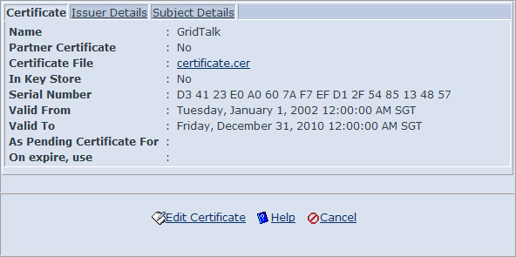

When importing a certificate, on selection of the certificate file and clicking on the Add/Remove File(s) hyperlink, these three attributes will also be displayed for the selected certificate.

Partner CA Certificate
Users are now allowed to import CA certificates into the application database as partner certificates, and export the import CA certificates to the trust store.

CA certificates can be imported using the same manner as a Partner Certificate, in which the Is CA option is available for selection. Selecting “Yes” would indicate that the selected certificate to be imported would be used as a CA certificate, “No” indicates a normal partner certificate.

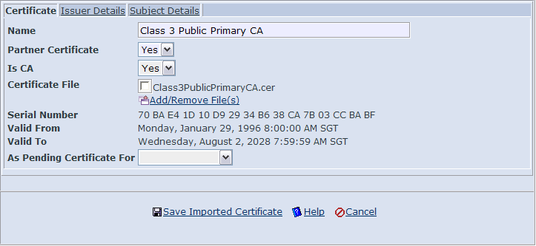

In the Partner Certificates listing, the Is CA field is shown as configured:
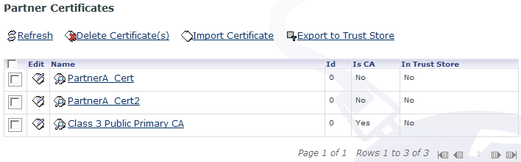

The Is CA field is also editable in the Edit mode of the Partner Certificate.

When exporting partner certificates to the trust store, the parent CA certificates should be exported first to the trust store, before exporting the end-entity certificates. Otherwise, the application would complain that the parent certificate is not in the trust store.

IMPORTANT NOTE:
Only valid certificates may be exported to the trust store. This means that, even if the end-entity certificate is valid, if its parent certificate is not valid and not already in the trust store, the end-entity certificate could not be exported to the trust store, since its parent certificate could not be exported to the trust store.

Alert Notification on Certificate Expiry
A certificate expiry checking mechanism is put in place to carry out routine checking of the validity of the certificates in the application certificate database. This routine checking starts when the GridTalk application is installed, or when an existing GridTalk application is updated to v 4.0.2. The default schedule is set to be daily at the time of installation or update. This schedule may be changed from the Scheduled Task listing.

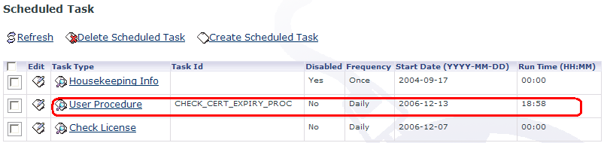

When the routing checking is carried out, all non-revoked certificates existing in the GridTalk application database would be checked for validity. If a certificate has already expired, or is due to expire in N number of days at the time of checking, an alert notification would be triggered. The variable N is the number of days to remind the administrator before the certificate becomes expired. Therefore, if N is 30, then 30 days before the certificate becomes expired, the application would start sending out alert notifications, daily, on this certificate coming expiration. This variable may be changed by editing the daysBefore parameter of the CHECK_CERT_EXPIRY_PROC user procedure. Another parameter daysAfter allows the application to continue sending alert notifications until the certificate has expired for the number of days. The default values for both parameters are 30 and 10 respectively.

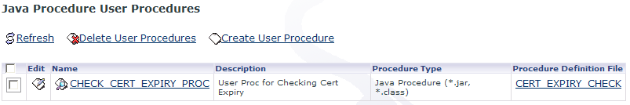

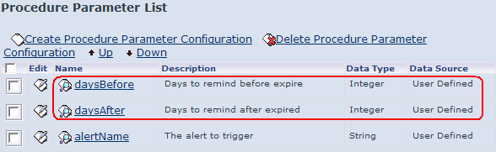

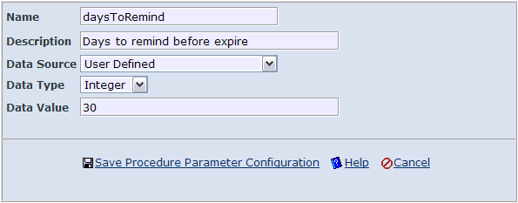

Bi-direction indication of Certificate Replacement
The existing way of indicating certificate replacement is at the replacement certificate (new certificate) whose As Pending Certificate For field indicates the expiring certificate. A bi-directional indication of certificate replacement is now put in place to allow viewing of the replacement certificate from the expiring certificate. This is achieved by the On expire, use field, which is not editable on import or update of certificate. There is no change to the current way of specifying a replacement certificate for an expiring certificate, i.e. still using the As Pending Certificate For field.

Existing view from replacement certificate
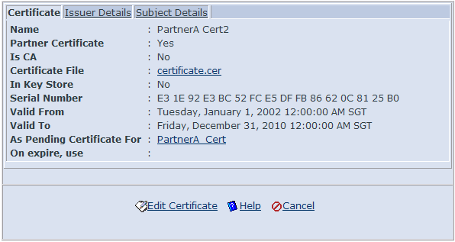

New view from expiring certificate
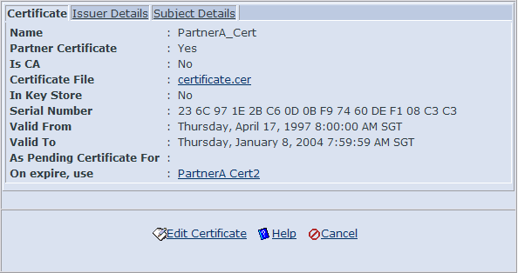

Archival Changes

Archival by Partner
The Archive Documents function is enhanced with an additional criterion: Partner. This can be specified for both Process Instance and Document archive types. Selecting the partners (by moving them to the right list box) would only include process instances or documents that involved the selected partners.



Archive Search and Restore
A search feature is implemented for searching archived documents and process instances. This search feature is not turned on by default; it needs to be enabled when configuring the archival options.

Previously, data archived are restorable by default. It is now configurable to enable restore or just purge the archived data. This option is configurable on every archival.

To enable searching, the Enable Search option must be checked.
To enable restore, the Enable Restore option must be checked.
If none of the options are checked, the archived data will be permanently removed from the application database and file system.

For details on Archive Search, refer to GridTalk 4.0 Administrator Guide, Chapter 14.

Archival Process
The archival process is enhanced to ensure that on event of archival failures, all documents associated with the un-archived process instances are still intact.

Previously, the associated documents for the process instances are always archived and removed from the transaction database before the process instances are archived. This often resulted in documents being archived but the process instances failed to be archived and the process instances are left-over without any associated documents.

The archival process is revised such that process instances are archived in batches (a batch consists of maximum 100 process instances and their associated documents) and only on successful archival of each batch will the archived process instances and documents be removed from the transaction database.

Archival Alerts
The alert notifications templates for archival are revised as follows:
- Upon start of the archival process, a new alert email is sent to the Administrator (default), notifying of the start of archival. The archival criteria are included with the email.
- The original alert email sent upon completion of archival process (regardless of success or failure) is divided into two emails: one for successful completion, another for failure in execution. For both emails, the archival criteria are included with the email, as well as the archive summary file, which is attached with the email.
- The successful completion email would include the total number of process instances or documents archived. The failure in execution email would include the exception errors that were encountered during the archival process that caused the failure.

Known Issues

Functional Issues

Operational Issues

Export of document without file extension
The Export function will not work under the following scenarios:

Scenario 1:
- The destination export directory of the user document or attachments already contains a folder with the same name as user document or attachments.

Scenario 2:
- The user document does not contain file extension – this refers to two possible scenarios:
- the user document itself not containing a file extension
- the Different Filename option is chosen and the Filename specified does not contain a file extension
- There are attachments to export – this refers to two possible scenarios:
- The document itself have attachments when it’s received or imported
- The Export GDoc option is chosen
- The Group Attachments Only option is chosen for the File Grouping field

This is due to the fact that operating systems do not allow a file and a directory of the same name, in this case, the file refers to the user document and the directory refers to the attachment directory that is named after the user document filename (without file extension).

Communication Issues

Document Issues

Non-Functional Issues
N/A

Release Packs

Installation Packs

Build 4.0.0

Installation on Windows

Zip Installation
Package Filename: GridTalk4.0.0_jBoss_win_full.zip

- Unzip the package into the desired GridTalk installation directory, say, C:\GridNode
- This will extract all contents from the zip file grouped by a GridTalk4.0.0 directory. After extraction, you may rename the directory to a shorter name, say, GridTalk.
- Set the GRIDTALK_HOME environment variable in Windows to the GridTalk directory, for example, C:\GridNode\GridTalk
- Start up the application using the startup.bat script located at GRIDTALK_HOME\bin directory.

IMPORTANT NOTE: The installation directory name/path must not contain whitespaces, such as: C:\Program Files\GridTalk. The application would not be able to startup or run properly if it is installed under such directory.

Install as Windows Service
- Remove all existing GridTalk Windows Services from the Control Panel\Administrative Tools\Services console. These may include “jBoss” and “mySQL” from V2.4 series, and “GridTalk_AS”, “GridTalk_DB”, and “GridTalk_Logger” from V4.0 series.
- If GridTalk application is running, shut it down using the shutdown.bat located at GRIDTALK_HOME\bin directory.
- Double-click the service.bat located at GRIDTALK_HOME\bin directory.
- Type I when asked whether to install or remove services.
- This will install the GridTalk application as Windows Service and start the application at the same time.

Build 4.0.1

Installation on Windows

Executable
Package Filename: GridTalk4.0.1_jBoss_win.exe

- Double-click on the file to start the installation
- Follow through the instructions on screen to install.
- There will be two application shortcuts created in Program Files for you to start and shutdown the GridTalk application.

Zip Installation
Package Filename: GridTalk4.0.1_jBoss_win_full.zip

- Unzip the package into the desired GridTalk installation directory, say, C:\GridNode\GridTalk
- Set the GRIDTALK_HOME environment variable in Windows to the GridTalk directory, for example, C:\GridNode\GridTalk
- Start up the application using the startup.bat script located at GRIDTALK_HOME\bin directory.

IMPORTANT NOTE: The installation directory name/path must not contain whitespaces, such as: C:\Program Files\GridTalk. The application would not be able to startup or run properly if it is installed under such directory.

Install as Windows Service
- Remove all existing GridTalk Windows Services from the Control Panel\Administrative Tools\Services console. These may include “jBoss” and “mySQL” from V2.4 series, and “GridTalk_AS”, “GridTalk_DB”, and “GridTalk_Logger” from V4.0 series.
- If GridTalk application is running, shut it down using the shutdown.bat located at GRIDTALK_HOME\bin directory.
- Double-click the service.bat located at GRIDTALK_HOME\bin directory.
- Type I when asked whether to install or remove services.
- This will install the GridTalk application as Windows Service and start the application at the same time.

Installation on SunOS (AMD 64-bit or Sparcv9)

Executable
Package Filename: GridTalk4.0.1_jBoss_solaris_amd64.sh
GridTalk4.0.1_jBoss_solaris_sparcv9.sh

- Run the script file to start the interactive installation
- Follow through the instructions on screen to install.
- There will be two application shortcuts created in Desktop for you to start and shutdown the GridTalk application.

IMPORTANT NOTE: The installation directory name/path must not contain whitespaces, such as: /usr/local/bin/Gridnode Software/GridTalk. The application would not be able to startup or run properly if it is installed under such directory.

Build 4.0.2

Installation on Windows

Executable
Package Filename: GridTalk4.0.2_jBoss_win.exe

- Double-click on the file to start the installation
- Follow through the instructions on screen to install.
- There will be two application shortcuts created in Program Files for you to start and shutdown the GridTalk application.

Zip Installation
Package Filename: GridTalk4.0.2_jBoss_win_full.zip

- Unzip the package into the desired GridTalk installation directory, say, C:\GridNode\GridTalk
- Set the GRIDTALK_HOME environment variable in Windows to the GridTalk directory, for example, C:\GridNode\GridTalk
- Start up the application using the startup.bat script located at GRIDTALK_HOME\bin directory.

IMPORTANT NOTE: The installation directory name/path must not contain whitespaces, such as: C:\Program Files\GridTalk. The application would not be able to startup or run properly if it is installed under such directory.

Install as Windows Service
- Remove all existing GridTalk Windows Services from the Control Panel\Administrative Tools\Services console. These may include “jBoss” and “mySQL” from V2.4 series, and “GridTalk_AS”, “GridTalk_DB”, and “GridTalk_Logger” from V4.0 series.
- If GridTalk application is running, shut it down using the shutdown.bat located at GRIDTALK_HOME\bin directory.
- Double-click the service.bat located at GRIDTALK_HOME\bin directory.
- Type I when asked whether to install or remove services.
- This will install the GridTalk application as Windows Service and start the application at the same time.

Installation on SunOS (AMD 64-bit or Sparcv9) and Linux

Executable
Package Filename: GridTalk4.0.2_jBoss_solaris_amd64.sh
GridTalk4.0.2_jBoss_solaris_sparcv9.sh
GridTalk4.0.2_jBoss_linux.sh

- Run the script file to start the interactive installation
- Follow through the instructions on screen to install.
- There will be two application shortcuts created in Desktop for you to start and shutdown the GridTalk application.

IMPORTANT NOTE: The installation directory name/path must not contain whitespaces, such as: /usr/local/bin/Gridnode Software/GridTalk. The application would not be able to startup or run properly if it is installed under such directory.

Upgrade Packs

Build 2.4.8 – 4.0.1

Windows Platform
Package Filename: GridTalk2.4.8_jBoss_win_upgrade4.0.1.zip

- Unzip the package to a temporary folder, say, C:\upgrades
- This will extract the package contents, grouped under “GridTalk2.4.8_jBoss_win_upgrade4.0.1” folder, to the temporary folder.
- You will require jakarta-ant-1.5.1-bin.zip to be installed in order to run the patch. If you have not done so, just unzip the package under the same directory that contains your GridTalk, e.g. if GridTalk is installed at C:\GridNode\GridTalk, unzip the package under C:\GridNode folder.
- Ensure that the GridTalk application is not running before applying the upgrade pack. If the application is running, stop it using the shutdown.bat located at the GRIDTALK_HOME\bin directory.
- Run the upgrade.bat file located directly under the unzipped “GridTalk2.4.8_jBoss_win_upgrade4.0.1” folder.
- This will upgrade your existing V2.4.8 GridTalk to V4.0.1.
- If your GridTalk application needs to be run as a Windows Service, follow instructions in Section 6.1.2.1.3 Install as Windows Service.

NOTE:
After upgrade, the database, JBoss, and JRE used by V2.4.8 will become obsolete. You may like to archive those folders (“mysql_2.4”, “jboss-3.2.2”, and “jre142_05”) to your backup file system, or remove them totally if you have already done backup of V2.4.8 prior to the upgrade.

Patches

Build 4.0.0 – 4.01

Windows Platform
Package Filename: GridTalk4.0.0_jBoss_win_patch4.0.1.zip

- Unzip the package to a temporary folder, say, C:\patches
- This will extract the package contents, grouped under “GridTalk4.0.0_jBoss_win_patch4.0.1” folder, to the temporary folder.
- You will require jakarta-ant-1.5.1-bin.zip to be installed in order to run the patch. If you have not done so, just unzip the package under the same directory that contains your GridTalk, e.g. if GridTalk is installed at C:\GridNode\GridTalk, unzip the package under C:\GridNode folder.
- Ensure that the GridTalk application is not running before applying the patch. If the application is running, stop it using the shutdown.bat located at the GRIDTALK_HOME\bin directory.
- Run the patch.bat file located directly under the unzipped “GridTalk4.0.0_jBoss_win_patch4.0.1” folder.
- This will patch your existing V4.0.0 GridTalk to V4.0.1.

